The Negative Impacts of Social Media on Adolescents’ Mental Health

|  |  |
| --- | --- |
| **Team Member** | **Student ID** |
| Anoushikha Ginni | 24452195 |
| Jessica Nguyen | 13289576 |
| Joell Balakrishnan | 24547630 |
| Gigi Tsai | 14294286 |
| Ann Jain | 14294831 |
| Ji Ho Lee | 24514844 |
|  | |
| **Tutorial Activity Code** | 3 |
| **Day/Time** | Friday 10am |
| **Name of tutor** | Thomas Dolmark |
| **Submission Date** | 20/10/2024 |

# Executive Summary

This report analyses the negative impact of social media has on the mental health of adolescents aged 12-18. The primary problem consisted of negative outcomes such as addiction, cyberbullying, and unhealthy social comparisons leading to anxiety and depression. Several potential solutions were evaluated against feasibility criteria, which resulted in narrowing down to two solutions which were: an AI chatbot integrated into social media platforms, and the creation of a mental health safe space in schools.

The AI chatbot aimed to provide personalized mental health support via its chat feature, while also monitoring and filtering online content. The mental health safe space initiative provides a supportive environment within schools for adolescents to disconnect from social media, receive guidance and discuss with peers and teachers on the dangers of social media. The final solution chosen was the safe space initiative as certain criteria such as ease/cost of implementation and higher levels of engagement made it the most feasible solution for addressing the problem of adolescents’ mental health impacted negatively by social media.

# Table of Content

Executive Summary 2

Table of Content 3

Introduction 4

Body – Discussion 5

Task 1 – Modelling, Evaluation and Selection 5

1.1 Deeper Understanding of the Problem 5

1.2 Ideation for Possible Solutions 7

1.3 Evidence of Ideas Evaluation 9

Option Analysis in Accordance with Criteria 10

Task 2 – Proposition, Analysis and Assessment 12

2.1 Development of Selected Solutions 12

2.1.1 AI Chatbot 12

2.1.2 High School Safe Space 12

2.2 Deeper Understanding of the Solutions 13

2.3 Context analysis of selected solutions 17

2.4 Predicting the Impacts of the Solutions 19

2.4.1 Systems Dynamics Model on Impact of Solutions 19

2.4.2 Improvement Criteria for Solutions 20

Task 3 – Feasibility and Industry Viability 21

3.1 Value Proposition 21

3.2 Implementation Plan 24

3.3 Business Model Canvas 26

Conclusion 27

Appendices 28

References 29

# Introduction

The rise in social media usage has significantly transformed global communication for all people, especially for adolescents. According to Zote (2024), 95% of adolescents aged 12-18 use YouTube, 74% Instagram, and 62% TikTok. The dopamine rush of social validation often leads to social media addiction, which can expose adolescents to distressing content, increase social comparison with peers as well as cybervictimization. The problematic impacts of such exposure have been well documented to lead to the development of mental health disorders thus decreasing a teenager’s overall life satisfaction. DeAngelis, (2024) reported that 10% of teens in the highest social media usage group have expressed suicidal intent or self-harm in the past 12 months, compared to 5 % of students who used social media less. Therefore, such statistics reflect the urgent need to address the negative effects of social media on teenagers.

# Body – Discussion

## Task 1 – Modelling, Evaluation and Selection

### 1.1 Deeper Understanding of the Problem

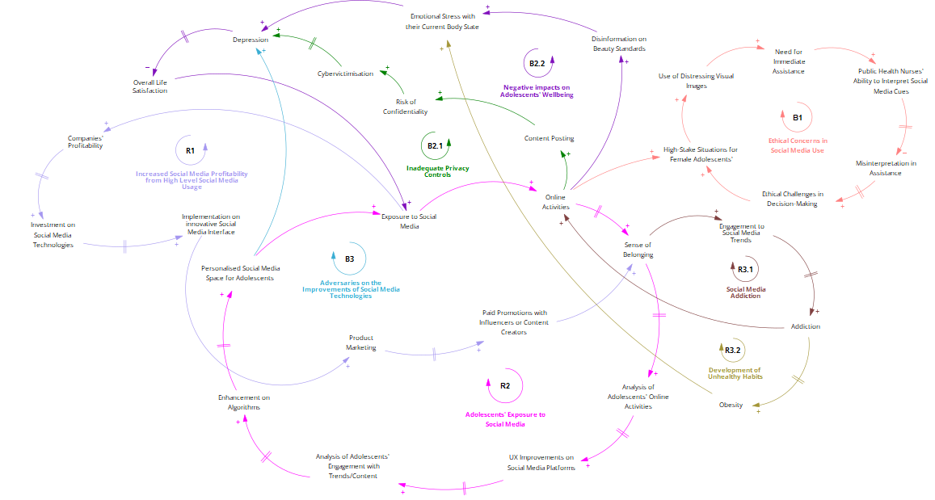

Figure 1. Causal Loop Diagram on the Wicked Problem

The use of social media interfaces for adolescents provides a place for connection with peers, which is exhibited in the reinforcing loop (R2). The active engagement to these interfaces is due to a psychological effect, where they experience a sense of belonging and the pressure to utilise social media due to peer influence (Livingstone, 2008). Social media companies extrapolate adolescent user data on trend and content interests, allowing to create various, integrated features, such as photo-filtering tools, gamified spaces, peer communication, leading to addiction.

This notion is accentuated by Rosen et al. (2014) where there is a gradual increase of addiction, compromising the wellbeing of adolescents illustrated in the reinforcing loop (R2.1). Poleac and Babii (2024) highlights that social media algorithms are established by data curation of user preferences and trend interests. Although these enable for a greater usage through the social media companies’ profitability to create more improved and personalised platforms, this contributes to the increased addiction.

The balancing loop (B2.2) demonstrates the gradual process of depression and life dissatisfaction occurring when adolescents are prone to excessive social media usage. Papageorgiou et al. (2022) research explores the disinformation of unrealistic beauty standards pinned towards female adolescents, exacerbated from social media influencers’ content manipulation by brand companies’ marketing tactics. This can lead to detrimental concerns where vulnerable female adolescents are disturbed by their body appearances, causing their desire to risky surgical procedures. In conjunction to Poleac and Babii’s (2024) article on social media algorithms, this gradual development of stress is formed by such personalised appearance-related content leading to the deterioration in their mental health. As a result, this increases further social media use (Azem et al. 2023).

The use of social media technologies can face many ethical challenges. The balancing loop (B1) depicts the difficult decision-making process for public health nurses when it comes to adolescents seeking support (Laholt et al. 2019). This suggests social media technologies alone are insufficient for accurately determining whether adolescents are required for support due to the limitations of physical gestures. Ethical concerns are also highlighted by Poleac and Babii (2024) where elucidates how social media content is personalised for adolescent users without their consent.

Adolescents risk their confidentiality on video-sharing social media platforms (Kang et al. 2021). This promotes inadequate privacy regulations when adolescent users are actively posting content online to their public audience, resulting in in higher life dissatisfaction portrayed in the balancing loop (B2.1). Their limited understanding of the risks involved, because of the lack of social media education, such as safeguarding strategies.

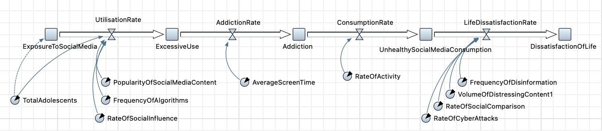Figure 2. Stock Flow Diagram on the Wicked Problem

As discussed previously based on Figure 1, social media platforms provide a personal hub for adolescents to interact with peers and other online activities, fueling obsessive use of these platforms, resulting in poorer life satisfaction. To understand the complexity of this problem, there are several measures that must be taken to achieve a possible solution shown in Figure 2. The analysis on the popularity of social media content and frequency of algorithms aid in resolving the ethical challenges faced in the use of social media. This will also help in the decline of depression and social media addiction that Rosen et al. (2014) matter, where measuring the content engagement that adolescents are immersed in. In addition, social media addiction can be reduced through the assessment of the rate of social influence and average screen time. It is significant that it is assessed as Rosen et al. (2014) depicts the linkage between increased screen time and greater obesity levels. As a result, this creates depression and low satisfaction with life in adolescents, particularly in female adolescents due to their unrealistic appearance-related concerns accentuated in Papageorgiou et al. (2022). Derived of unrealistic beauty concerns, the factors that correlate to this are the disinformation of social media content, distressing images shown that prone to further social comparisons and cyberattacks. Hence, it is crucial that these factors are measured to resolve the ramifications of social media influence against adolescents.

### 1.2 Ideation for Possible Solutions

Concerns about adolescents' social media usage have sparked significant discussions regarding its impact on life satisfaction and depressive symptoms (Rossi, C. 2014). In response, our group developed seven strategies to mitigate and lessen the negative effects of social media on young users.

1. **Ji Ho:** implementing age restrictions on social media platforms.
   1. Most applications have set a minimum age of 13 for user registration (Schneble, C. O. 2021), which theoretically limits adolescent access. However, these measures often fail to protect young users effectively, as they can easily create accounts by using just a phone number (Kang, H. 2021).
2. **Jessica:** designing an adolescent friendly user interface for an app that retains popular social media features.
   1. Incorporating elements like video sharing and customisable content feeds with 15 second to one-minute videos, the application would engage younger users more effectively (Kang, H. 2021).
3. **Jessica:** AI chatbot feature that would serve as a virtual mental health professional, providing a safe space for teenagers to discuss their mental health concerns.
   1. World Health Organization statistics indicate that one in seven individuals aged 10 to 19 experience mental disorders, with untreated issues potentially extending into adulthood and affecting overall wellbeing (World Health Organization, 2024).
   2. The chatbot's design aims to address these concerns directly, empowering adolescents to lead more fulfilling lives as adults. This approach has proven effective, with chatbots and virtual assistants successfully providing immediate mental health support (Thakkar, A. 2024).
4. **Gigi:** Using AI to filter and monitor social media platforms, removing harmful content.
   1. This method has been successfully applied on platforms like TikTok and Instagram, where AI systems automatically block posts which violate community guidelines (Barrett, P. 2024). Similarly, our proposed AI system should be able to filter harmful content affecting adolescent mental health.
5. **Anoushikha:** Creating a social media application exclusively for students within the Australian school district.
   1. This platform would aim to foster a supportive community among students, allowing them to connect with like-minded peers while avoiding harmful content prevalent on mainstream social media (Hansen, S. 2019).
   2. *Negative:* Students often seek spaces that feel personal and less monitored, which can drive them back to existing social media platforms.
6. **Joell:** Peer-led mental health support system outside of schools.
   1. These spaces, moderated by teachers, would facilitate open discussions and build trust between students and educators (Wan et al., 2023).
7. **Ann:** Incorporating lessons on responsible social media usage into the high school PDHPE curriculum.
   1. While the current Australian curriculum addresses mental health and well-being, it overlooks the specific impacts of social media on mental health. Teaching adolescents about the potential harms of social media would empower them to navigate these platforms more responsibly (ACARA, n.d).

Through our discussions, we emphasised the importance of each proposed solution, ultimately identifying that the mental health support space and AI virtual therapist were our strongest recommendations.

### 1.3 Evidence of Ideas Evaluation

Table 1. Selection criteria used to evaluate options, brainstormed by the team to account for feasibility of each solution.

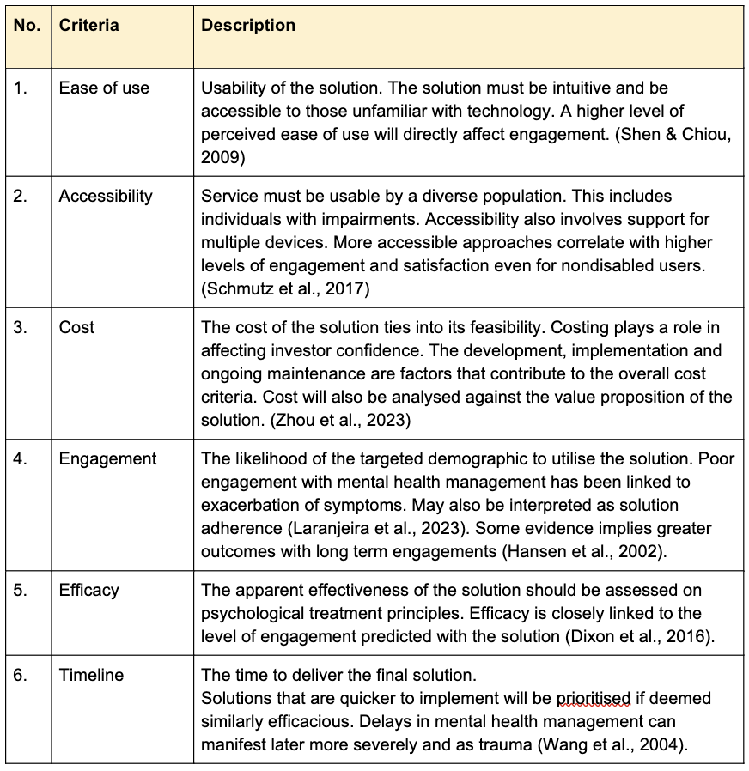

#### Option Analysis in Accordance with Criteria

Table 2. Option Analysis in Accordance with Criteria

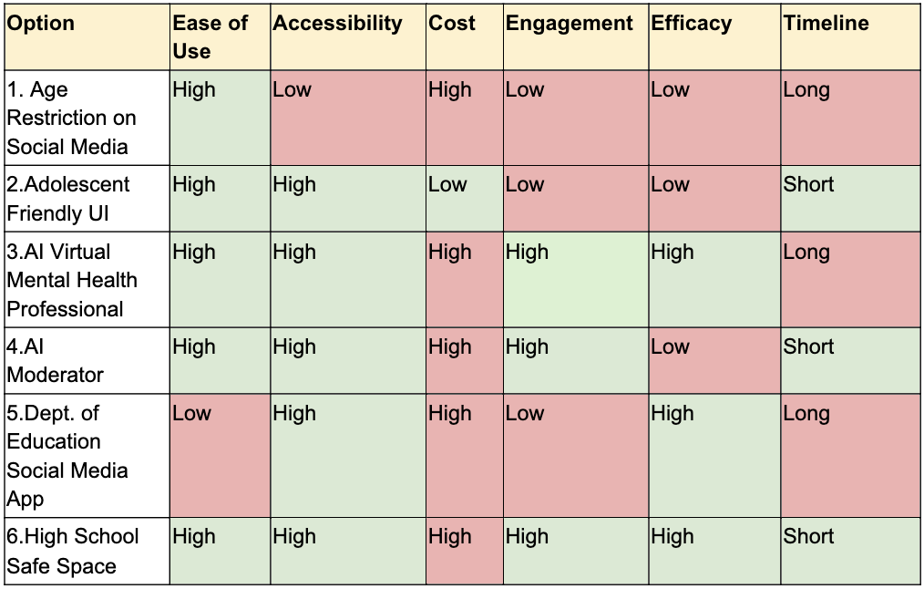

Table 2 provides a summary of the options compared against the selection criteria. Green highlights denote positive and conversely red represents negative aspects. The classifications were polarised to aid in option selection.

Exclusion of Solutions

Social media use is near-unavoidable and therefore restrictive methods can prove to be ineffective. This is evidenced by efforts made internationally to age-gate adult websites experiencing difficulties in compliance with workarounds existing in the form of utilising a VPN (Taylor & Rose, 2024). Content moderation in the form of user empowerment in option 2’s UI, align with engagement dependent efficacy. Ofcom, a UK government organisation, conducted a survey with only 26% of the 2000 subjects citing they have utilised content control features pointing towards a predicted lack of engagement with this approach (Ofcom, 2024). Although option 4’s moderation can circumvent the engagement issues, it fails to address the problem itself.

The solutions with the highest efficacy involve managing symptoms of the problem. Providing a replacement for traditional social media platforms (Option 5) is a promising approach though it is limited by the barrier of user engagement in such a competitive landscape. Lack of engagement may affect its efficacy. As such, the most likely options to manage the issue are the AI Chatbot and the Mental Health Safe Space Initiative.

AI Chatbot

Laholt et al. (2018) covers accounts of public health nurses dealing with adolescents in conjunction with social media. The article covered ways in which adolescents have leveraged technology by providing visual aids to garner a greater understanding of their environment through sharing media rather than relying on anecdotes. The AI Chatbot depicted differs from other existing solutions as it would be an integrated feature into social media platforms rather than a standalone application. It will be able to answer live messages and perform judgements on received media through voice and image recognition directly from personal content feeds.

If trained adequately, the chatbot can provide low-level counsel although escalation measures to professionals should be included for full coverage. AI can aid in the triaging of mental health patients which increases its value proposition in the long term over other interventions, even traditional therapy. The chatbot can form the first step in acclimating an individual to open to clinical treatment (Salaheddin & Mason, 2016). Younger demographics have preferred chat-based hotlines over voice-calls and face-to-face counselling (Brody et al., 2020). A successful implementation of this solution can lower the action required by parents and teachers whilst still managing the problem.

High School Safe Space

Safe space initiatives have been implemented in multiple tertiary educational institutions and are ubiquitous in communities outside of schools. Safe spaces provide a non-clinical, peer-led support system for people distress. Much like that AI chatbot, it can form as the first step into seeking professional help. Gunawardena et al. (2024) refers to teachers as mental health ‘first responders.’ Teachers have high exposures to adolescents and can oftentimes detect deteriorating mental health through sudden changes in academic outcomes or classroom behaviour. Although they may be able to recognise there is an issue, the line of care ends due to a lack of training.

Creating a learning outline centred around social media education can produce positive outcomes for adolescents. This solution can incorporate aspects of the other solutions. The space moderator can produce learning materials about content curation to empower adolescents in their social media consumption. They can also mirror the referral process featured in the AI chatbot of adolescents to mental health professionals by initiating the parent teacher dialog (Anderson-Butcher, 2012 & Wang et al., 2004).

## Task 2 – Proposition, Analysis and Assessment

### 2.1 Development of Selected Solutions

#### 2.1.1 AI Chatbot

Firstly, the integration of AI moderation and Chatbot in social media platforms supports adolescents in intervening interactions that contribute to mental health concerns, such as cyberattacks or social comparisons. This benefits the filtering process of social media algorithms for adolescents. Additionally, media awareness is integrated in the AI chatbot, curating social media content, to mitigate adolescents’ exposure to detrimental behaviours. As adolescents in this age group obtain the highest level of unhealthy consumption driven by media addiction, leading to limited physical activity and increase depression. The third feature facilitates a personalised chat environment for adolescents to share their emotional circumstances, when encountered challenges on social media content. It can identify self-harm cases or keywords, escalating to professional assistance, if required. Lastly, it fosters a supportive network for adolescents through parental-teacher involvement by reducing social comparisons and improves the adolescents’ self-esteem overall.

#### 2.1.2 High School Safe Space

This safe space is offered in an inclusive, high school for adolescents in this age group, engage in open discussions with other emotionally vulnerable adolescents and seek support. This aims to improve the adolescents’ overall wellbeing. Secondly, it provides social media education that teaches adolescents healthy, effective habits when utilising social media. Adolescents are given case-study modules to assess and apply their understanding in handling cybervictimisation and content judgement. Similarly to the AI chatbot, this high school safe space can also promote teacher involvement in escalating adolescents to mental health support, enhancing their overall wellbeing and minimise social comparisons. It is also comparable to the AI chatbot’s role in providing professional mental health support for emotionally distressed adolescents, however the support is facilitated by teacher involvement.

### 2.2 Deeper Understanding of the Solutions

Table 3. In Scope and Out-of-Scope Requirements for AI Chatbot

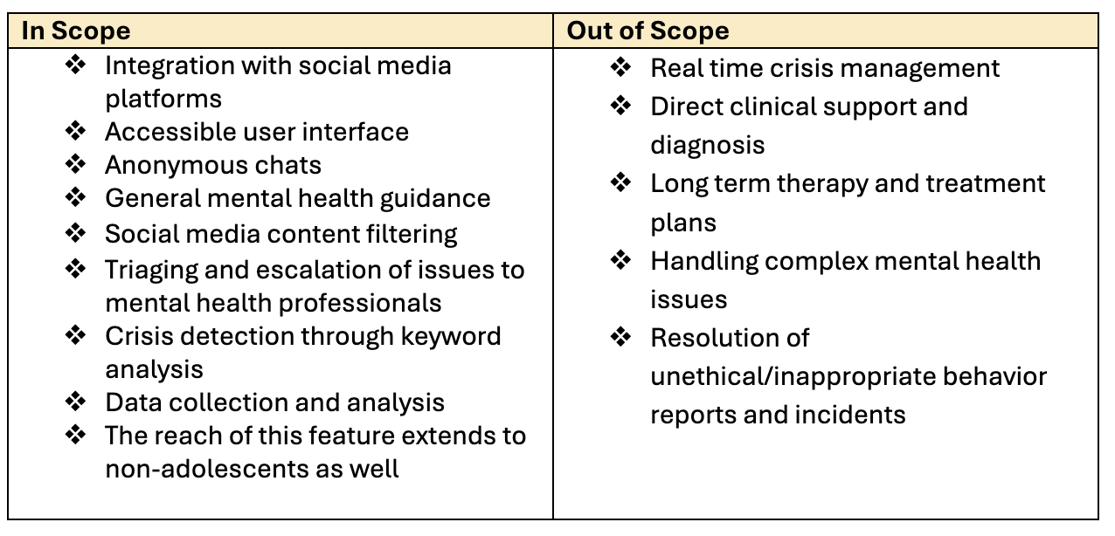

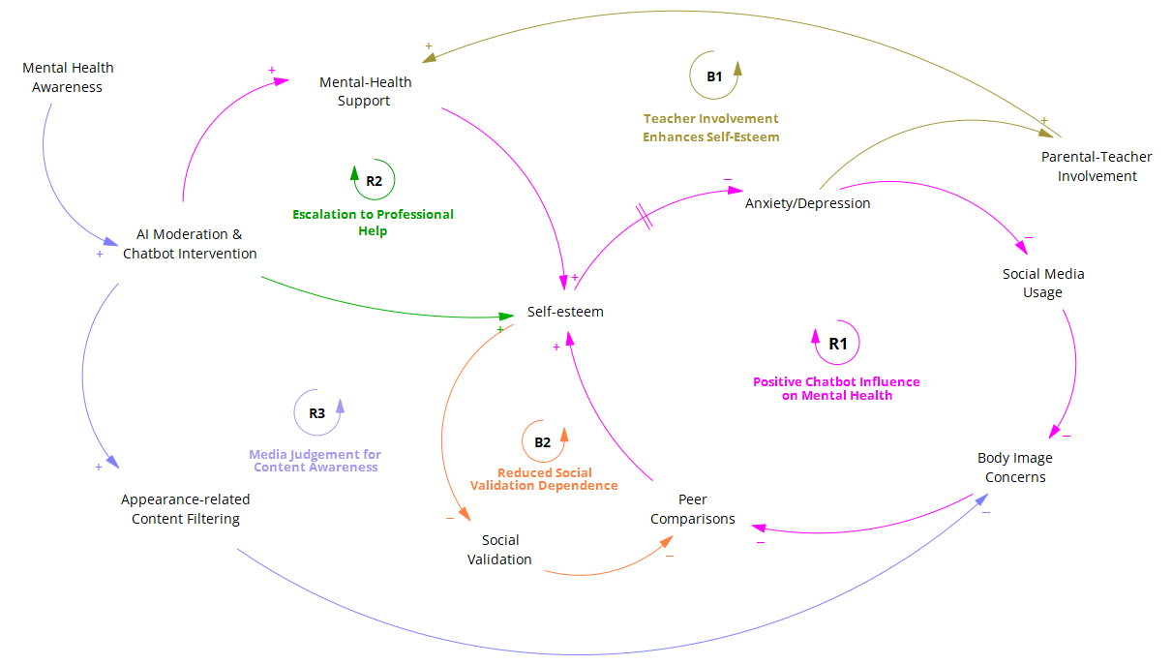Figure 3. Causal Loop Diagram on Solution 1 AI Chatbot

**R1 – Positive Chatbot Influence on Mental Health**

As the AI chatbot provides mental health support, including AI moderation and anonymous chat sessions, adolescents' self-esteem improves, eventually reducing anxiety/depression. (Boucher et al., 2021, p.37) attests to this, reinforcing how an increase in access to digital innovations makes digital solutions to mental health care an “important avenue to addressing accessibility issues with traditional in-person care”.

The reduction in anxiety/depression encourages adolescents to limit unhealthy social media usage, which decreases body image concerns, as they are exposed to less deceiving and addictive content online (Khosla, 2024). As a result of this, there is a reduction in peer comparison, which ultimately loops back into improving self-esteem.

**R2 – Escalation to Professional Help**

The AI chatbot escalates to mental health professionals/emergency services any crises or serious mental health issues it detects through conversation with adolescents and monitoring of search activity on the application. This in turn increases the rate of adolescents seeking and receiving professional mental health support and as a result improves their self-esteem.

**R3 – Media Judgement for Content Awareness**

Adolescents’ mental health awareness increases as they engage with the AI chatbot whenever they access a social media platform. The AI chatbot provides feedback on and moderates harmful content shared by users, by using content filtering algorithms to analyse and moderate the content they are exposed to through flagging, blocking and providing warnings (Thieme, et al., 2023). This in turn, reduces body image concerns amongst adolescents which has been proven to be exacerbated by social media (Khosla, 2024).

**B1 – Teacher Involvement Enhances Self-Esteem**

Accounting for the context of the adolescent, high levels of anxiety/depression can increase teacher or parental involvement, who escalates issues to mental health support professionals where necessary.

**B2 – Reduced Social Validation Dependence**

As the self-esteem of adolescents are uplifted through interaction with the AI chatbot, their desire for social validation and peer comparison decreases.

Table 4. In Scope and Out-of-Scope Requirements for Safe Space

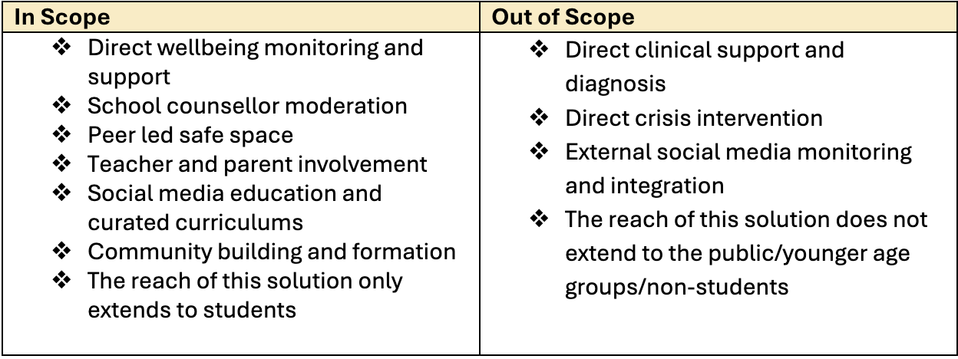

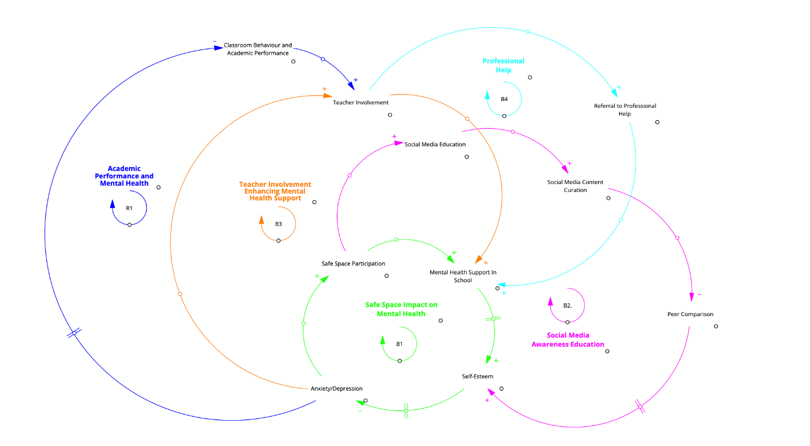

Figure 5. Causal Loop Diagram on Solution 2 High School Safe Space

**B1 – Safe Space Impact on Mental Health**

As adolescent engagement in high school safe spaces increases, mental health support in school increases and self-esteem of students advances. As a result of this, the student’s anxiety/depression decrease and safe space participation increases again, with students realizing the benefits of the program and engaging with it to maintain the improvements they have made.

**B2 – Social Media Awareness Education**

As adolescents participate in the safe spaces, they are provided with quality social media education, which in turn enhances their ability to appropriately curate and filter through content. As a result, their proclivity for peer comparison decreases and in turn their self-esteem increases.

**B3 – Teacher Involvement Enhancing Mental Health Support**

As students show signs of anxiety/depression, the involvement of teachers increases. (Gunawardena et al, 2024) explains how teachers are usually the first point of contact when an adolescent faces a mental health crisis, and that they often instigate a triage system where the school implements strategies of care and contacts mental health specialists.

While the article indicates that teachers often don’t feel well prepared for handling these situations, the safe space aims to assist in this by incorporating school counsellors and creating an open environment to discuss mental health issues. This in turn tries to avert crises and instead promotes gradual referrals to professionals. This then fosters and grows the extent of mental health support in schools.

**B4 – Professional Help**

The involvement of teachers/counsellors allows for experienced and trained staff to triage and support the mental issues students may be experiencing. This then increases the referral of more serious matters to professional help, with this practice once again sustaining mental health support in schools.

**R1– Academic Performance and Mental Health**

Students facing higher levels of anxiety and depression lead to a decrease in academic performance and classroom behaviour, which then instigates the involvement of teachers. The support of teachers and their referral of students to the safe space program reinforces the mental health support in schools, which in turn increases the students' self-esteem and decreases their anxiety and depression.

### 2.3 Context analysis of selected solutions

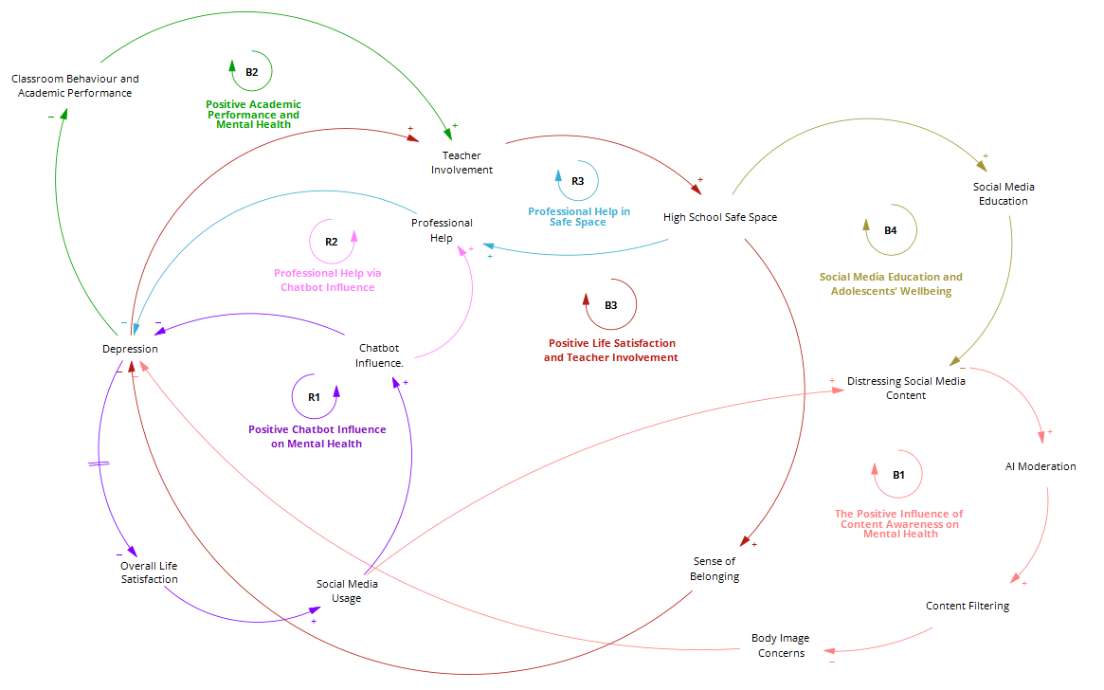Figure 7. Causal Loop Diagram on Context of the Selected Solutions

Figure 7 displays a causal loop diagram that portrays how the two proposed solutions can intervene in the context of the problem in focus.

**B1 – The Positive Influence of Content Awareness on Mental Health**

Social media usage, which is the root cause of our problem, increases adolescents' exposure to distressing social media content. In this context, the AI chatbot can be integrated as its AI moderation capabilities applies content filtering which assists adolescents with navigating social media content.

This in turn, decreases adolescent's body image concerns and ultimately decreases depression.

**B2 - Positive Academic Performance and Mental Health**

One of the significant effects of social media usage on adolescents is depression, which has been reported to negatively impact their classroom behaviour and academic performance. The decline in performance at school triggers an increase in teacher involvement and hence referral to the high school safe space.

**B3 - Positive Life Satisfaction and Teacher Involvement**

Echoing B2, symptoms of depression amongst the students increases teacher involvement who in turn refer the students to the high school safe space, increasing participation in program.

According to (Khosla, 2024), adolescents access social media applications to “harbor ways and means that help in developing their identity” and to have a “safe space to express and voice their stories”. Hence, involvement in the High School Safe Space captures this need and increases the student's sense of belonging as they become a part of likeminded peer led communities.

**B4 – Social Media Education and Adolescents’ Wellbeing**

The High School Safe Space, with tailored educational resources and qualified school staff, increases the delivery of social media education. This then decreases the student's engagement with distressing social media content as they have been trained in how to navigate the digital landscape.

**R1 – Professional Help in Safe Space**

Student participation in the High School Safe Space increases the detection and referral of students to professional help which reduces depression amongst students.

**R2 – Professional Help via Chatbot Influence**

Similar to R1, the influence of the AI chatbot on adolescent's usage of social media increases referral to professional help.

**R3 – Positive Chatbot Influence on Mental Health**

Depression decreases overall life satisfaction for adolescents which in turn increases social media usage. With the implementation of the AI chatbot, an increase in social media usage also increases the influence of the chatbot, which with its mitigative mechanisms decreases depression amongst adolescents.

### 2.4 Predicting the Impacts of the Solutions

#### 2.4.1 Systems Dynamics Model on Impact of Solutions

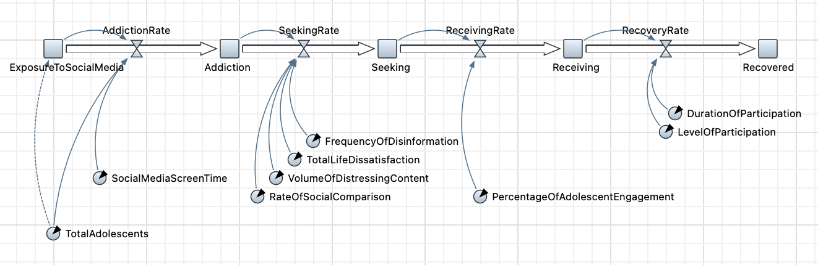Figure 8. Stock Flow Diagram on the Safe Space solution

In Figure 8, the stock flow maps out key components influencing adolescent mental health and the impacts of solutions to combat their declining mental health. This model consists of five primary stocks: exposure to social media, addiction, seeking, receiving and recovered. The stocks are interconnected through different flows which represent the rate of addiction, seeking solutions, receiving treatment and care and their recovery. The first stock, exposure to social media is driven by the total adolescent population which determines the level of potentially affected. Addiction arises depending on their social media screen time where the increase of screen time determines their rate of addiction. This is since teenagers are drawn in to using social media as it allows them to create their own online identities and communicate and connect with others (Mayo Clinic staff, 2024). Individuals who have a high screen time tend to experience an increase in mental health illnesses due to the frequency of disinformation and volume of distressing content leading to their life dissatisfaction and increasing rate of social comparison with other individuals, increasing the rate of seeking help. As adolescents seek solutions, they begin to engage with mental health interventions such as the proposed solutions, using a mental health safe space and an AI mental health professional chatbot. The receiving rate is impacted by the percentage of adolescent engagement with mental health solutions. Recovery is captured through the recovery rate determined by the duration and level of participation with the solutions, leading to the final stock, recovered. This structure ensures that each stock and flow is properly interconnected and represented to highlight the detailed processes behind adolescent mental health challenges and recovery with social media.

#### 2.4.2 Improvement Criteria for Solutions

1. Personalisation of Support

The chatbot is limited in its ability to provide tailored support and will benefit from the integration of personalised conversations. This will allow adolescents to receive tailored support based on their emotional state. The chatbot’s ability to assess their mental wellbeing through humanised questions and answers will allow for more targeted support. The chatbot should be able to detect emotional cues and adjust their responses accordingly to make the interaction more meaningful and more effective. The impact of this would be improving support surrounding adolescent mental health. Teenagers are likely to engage with solutions which feel relevant to their experience rather than being fed the same robotic answers, reducing the likelihood of harmful comparisons and self-esteem issues.

1. Crisis Detection and Intervention

The AI Chatbot does not feature a failure detection mechanism which handles false alarms or minor emotional triggers which may set off the crisis alert. By integrating failure detection mechanisms, the chatbot will be able to perform more efficiently providing support to the adolescents.

1. Engagement and Accessibility

The safe spaces may not be accessible to all adolescents with limited physical access to these spaces, highlighting the need for virtual professional companionship. By integrating a way for adolescents to contact these centers online, they will be able to continue with focusing on their mental health.

1. Addressing Root Causes of Addiction

A mental health safe space may not be able to provide the root cause of an issue as teenagers may struggle with opening about their mental health. A personalised connection must be developed between the moderator and the adolescent. This could be done through implementing bonding activities and more personalised conversations, allowing individuals to feel better about sharing their mental health issues.

1. Scalability and Integration into Social Media

The AI Chatbot must be able to integrate seamlessly with current social media applications and be built with the ability to scale rapidly to cater to the demand of all adolescents. By ensuring its scalability and seamless integration, adolescents will be inclined to utilise the feature. Technical interoperability with popular platforms will be key to ensuring the chatbot can access any relevant data and function without any lag.

## Task 3 – Feasibility and Industry Viability

### 3.1 Value Proposition

Figure 9. Value Proposition for Safe Space

1. In-person, Interactive Judgement Free Space for Open Conversations

The safe space initiative provides value to adolescents as it is a non-judgmental, non-clinical physical space for young people to relieve emotional distress and participate in healthier social and physical activities. The dopamine rush received from artificial feelings of validation through social media will be replaced with the dopamine release from real life connections (Newport Academy, 2023).

1. Access to Professional Support

Particularly empathetic and compassionate teachers will be chosen to support the safe space initiative. They will be responsible for encouraging productive dialogue about social media addiction and techniques for students to combat it. If teachers notice particular students struggling with their mental wellbeing, there will be efficient referrals to mental health professionals beyond the program.

1. Learning Modules

The safe space will also feature teacher lead activities that focuses on social media education. Students become equipped with the knowledge of how and why social media is addicting and gain practical tools and techniques to avoid consumption of media.

1. Digital and Physical Resources

The workshops will often involve learning worksheets and tasks that can help students deal with current/ future negative emotions they may experience related to social media consumption.

1. Space for Self-Regulation

The safe space initiative allows students to recharge their energy without the reliance on social media. Students can utilise the space to reflect upon their feelings and regulate their emotions in a nonjudgmental and calm environment.

1. Group-based, Physical and Social Activities

The safe space encourages students to relate to one another and to make genuine social connections. To escape social media use, the safe space will promote participation in physical activities such as games of tag and group social activities like card or board games.

This solution will clearly benefit students aged 12-18 who are struggling with their mental health and want to escape the grip of social media addiction. The overall aim of the initiative is to create a sense of safety for students, and ultimately increase students' mental resilience and independence to deal with any negative emotions or experiences caused from overconsumption of media. After deeper engagement with the solution, genuine relationships formed on the basis of trust and acceptance will form, and general social media usage within the school community is projected to decrease.

The costs of our solution will be minimal as a generic high school environment will already own all the required resources of what is needed to create a safe space. This safe space can be positioned in a section of a library, or within a cosy classroom. Within this space there will be couches and beanbags and social activities such as board and card games. Creating a relaxing ambience within a busy school environment promotes positive sensory stimuli (Francis,2024) and encourages students to relate to each other instead of being on their devices. The only increase in cost from the school’s perspective will potentially be the salaries of the staff who are chosen to support these safe spaces. Therefore, this solution is cost effective.

To make the safe space viable, active student participation is vital. Teachers will need to promote it in the classrooms and personally encourage certain students to get involved. Building rapport and trust with students is essential for them to feel comfortable in participating in this initiative. Additionally, the safe space community can organise larger group activities beyond the confines of the space itself. Activities such as outdoor football, will attract new students, boost participation and increase the overall viability of this solution.

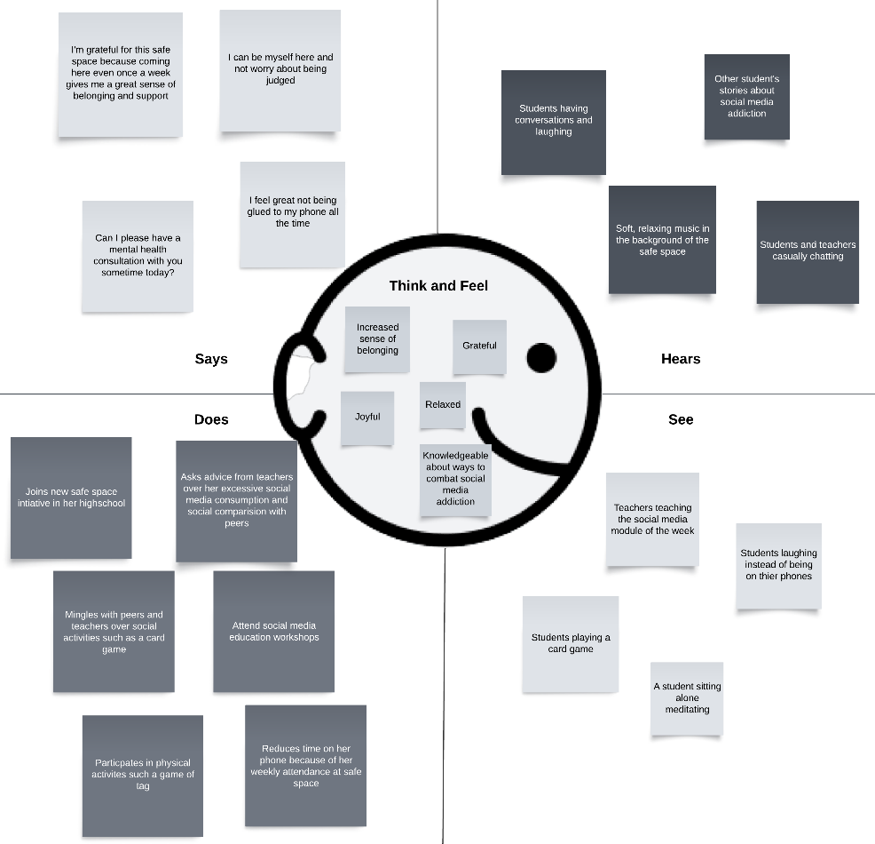

Figure 10. Empathy Map for Safe Space

Figure 10 represents a student’s experience participating in the safe space in their high school. From their perspective, they see the safe space as a relaxed and calm environment where they can engage in meaningful activities besides social media. This student enjoys socialising with peers and learning healthier digital habits from teachers. The students’ time spent in safe space has decreased their overall screen time and social media usage. Therefore, Figure 10 highlights the safe space’s projected success in influencing adolescent’s gradual disengagement from social media, thus decreasing its harmful impacts on their mental health.

### 3.2 Implementation Plan

Implementation of the safe space requires the project to be split into multiple phases. The initiation phase contains tasks needed to lay the foundation of the project, such as gathering information, requirements, and documents. This ensures that the rest of the project can progress smoothly.

The design phases cover the preparation and creation of the structure of the safe space. The curriculum, resources, and training are set up in these phases.

The implementation phase covers the tasks needed to roll out the program. The hiring of staff, conducting training sessions, and setting up of the physical safe space area are covered here.

Once the safe space has been set up and beginning to gather students, monitoring of the program through feedback and data collection is performed. This ensures that the program can be improved upon.

The final phase looks to expand the program into other areas, identifying funding sources to ensure long-term sustainability.

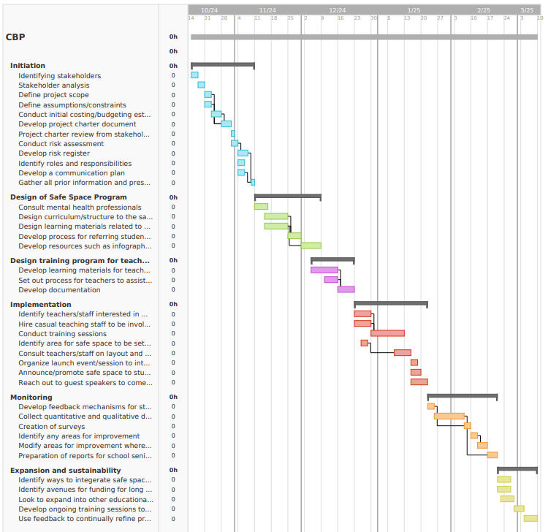Figure 11. Gantt Chart

### 3.3 Business Model Canvas

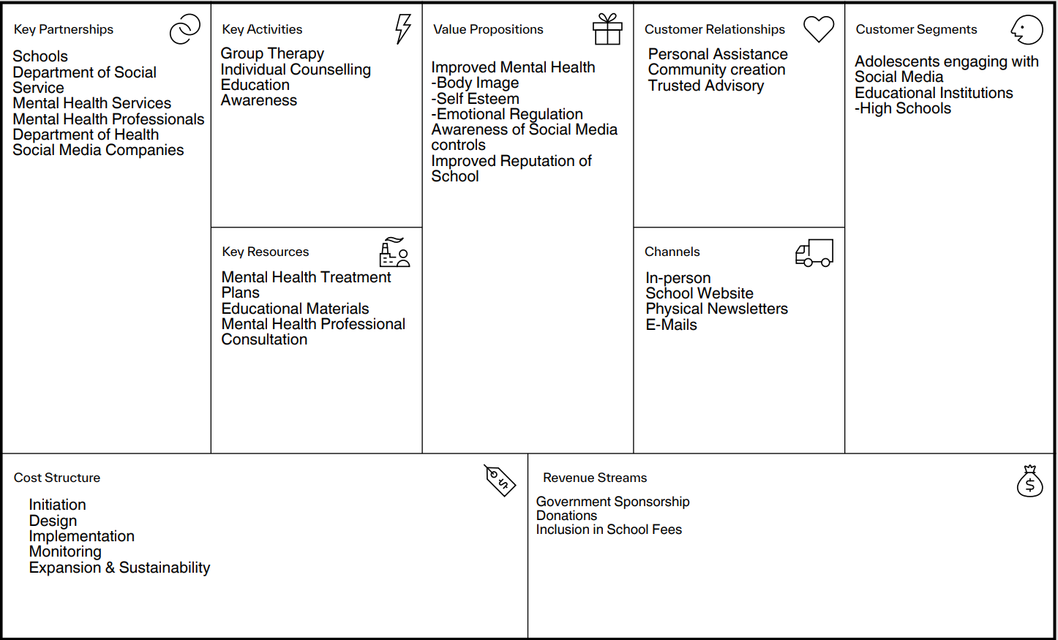Figure 12. Business Model Canvas

This is a completed business model canvas for the mental health safe space for adolescents. The solution will be heavily involved with the educational institution and associated government departments for its development and funding (NSW Health, 2020). Possible future engagements with representatives of social media companies can be fruitful in providing more specific learning materials for social media controls and therefore increase the value proposition for all parties. The key activities are centred around non-clinical and peer-led learning and counselling activities and focus on community creation. The solution will may be based on-site at schools and therefore its channels of delivery and awareness be confined to what is being used by schools currently.

# Conclusion

To combat the impact of social media on young adolescent’s mental health, particularly for females, several solution ideas were considered. Evaluating the solution ideas against criteria, two options were the most feasible: an AI chatbot that can be integrated within social media apps, and a mental health safe space within schools. Both solutions aim to provide adolescents with resources, support, guidance, and education to manage social media use, to avoid harmful effects and promote a healthier mental state.

Both qualitative and quantitative modelling was used to display the problem and the impact of the two solutions if they were to be implemented. The feasibility of the solutions was considered, and the final chosen solution was the mental health safe space within schools, as it matched most of the criteria in the evaluation. The report also includes an implementation plan on how the final solution would be implemented.

# Appendices

*No additional clarification of terms were needed in this report.*

# References

ACARA. (n.d.). *Australian curriculum: Health and physical education focus areas*. https://docs.acara.edu.au/resources/HPE_-_Focus_Areas.pdf

Academy, N. (2023). *Teen social media addiction and mental health*. https://www.newportacademy.com/resources/mental-health/teens-social-media-addiction/#:~:text=%E2%80%9CThe%20brain%20responds%20to%20social,the%20brain%2C%E2%80%9D%20says%20Kristin.

Anderson-Butcher, D. (2012). The role of the educator in early identification, referral, and linkage. In *SAGE Publications, Inc. eBooks* (pp. 257–274). https://doi.org/10.4135/9781452232355.n15

Barrett, P. M., & Hendrix, J. (2024, April 3). Is generative AI the answer for the failures of content moderation? *Tech Policy Press*. https://www.techpolicy.press/is-generative-ai-the-answer-for-the-failures-of-content-moderation/

Boer, M., Stevens, G. W. J. M., Finkenauer, C., de Looze, M. E., & van den Eijnden, R. J. J. M. (2021). Social media use intensity, social media use problems, and mental health among adolescents: Investigating directionality and mediating processes. *Computers in Human Behavior, 116*. https://doi.org/10.1016/j.chb.2020.106645

Boucher, E. M., Harake, N. R., Ward, H. E., Stoeckl, S. E., Vargas, J., Minkel, J., & Zilca, R. (2021). Artificially intelligent chatbots in digital mental health interventions: A review. *Expert Review of Medical Devices, 18*(sup1), 37–49. https://doi.org/10.1080/17434440.2021.2013200

Brody, C., Star, A., & Tran, J. (2020). Chat-based hotlines for health promotion: A systematic review. *mHealth, 6*, 36. https://doi.org/10.21037/mhealth-2019-di-13

DeAngelis, T. (2024). Teens are spending nearly 5 hours daily on social media. Here are the mental health outcomes. *American Psychological Association, 55*(3), 80. https://www.apa.org/monitor/2024/04/teen-social-use-mental-health

Dixon, L. B., Holoshitz, Y., & Nossel, I. (2016). Treatment engagement of individuals experiencing mental illness: Review and update. *World Psychiatry, 15*(1), 13–20. https://doi.org/10.1002/wps.20306

Francis, J. (2024). *Safe spaces, sound minds: Creating inclusive school environments that enhance perceived safety and improve mental health*. Retrieved from https://assets.csi.edu.au/assets/Slides-Safe-Spaces-Sound-Minds-Creating-Inclusive-School-Environments-that-Enhance-Perceived-Safety-and-Improve-Mental-Health.pdf

Galea, S., & Buckley, G. J. (2024). Social media and adolescent mental health: A consensus report of the National Academies of Sciences, Engineering, and Medicine. *PNAS Nexus, 3*(2). https://doi.org/10.1093/pnasnexus/pgae037

Gunawardena, H., Leontini, R., Nair, S., Cross, S., & Hickie, I. (2024). Teachers as first responders: Classroom experiences and mental health training needs of Australian schoolteachers. *BMC Public Health, 24*(1). https://doi.org/10.1186/s12889-023-17599-z

Hansen, N. B., Lambert, M. J., & Forman, E. M. (2002). The psychotherapy dose-response effect and its implications for treatment delivery services. *Clinical Psychology Science and Practice, 9*(3), 329–343. https://doi.org/10.1093/clipsy.9.3.329

Hansen, S. (2019, May 25). Exploring social media use in young people: What we know. *Your Psych Center*. https://www.yourpsychcentre.com.au/social-media-young-people/

Kang, H., Shin, W., & Huang, J. (2021). Teens' privacy management on video-sharing social media: The roles of perceived privacy risk and parental mediation. *Internet Research, 32*(1), 312-334. https://doi.org/10.1108/intr-01-2021-0005

Khosla, S. (2024, April 3). Exploring the influence of social media on body image: A study on adolescent girls. *ResearchGate*; Redshine Publication. https://www.researchgate.net/publication/379513264_Exploring_the_Influence_of_Social_Media_on_Body_Image_A_Study_on_Adolescent_Girls

Laholt, H., McLeod, K., Guillemin, M., Beddari, E., & Lorem, G. (2019). Ethical challenges experienced by public health nurses related to adolescents’ use of visual technologies. *Nursing Ethics, 26*(6), 1822-1833. https://doi.org/10.1177/0969733018779179

Laranjeira, C., Carvalho, D., Valentim, O., Moutinho, L., Morgado, T., Tomás, C., Gomes, J., & Querido, A. (2023). Therapeutic adherence of people with mental disorders: An evolutionary concept analysis. *International Journal of Environmental Research and Public Health, 20*(5), 3869. https://doi.org/10.3390/ijerph20053869

Livingstone, S. (2008). Taking risky opportunities in youthful content creation: Teenagers' use of social networking sites for intimacy, privacy, and self-expression. *New Media & Society, 10*(3), 393-411. https://doi.org/10.1177/1461444808089415

Muraleedharan, A. P. J., & S. P. (2021). Schools as safe spaces for adolescents: A mental health perspective. https://doi.org/10.31124/advance.13638041.v1

Mayo Clinic Staff. (2024, January 18). Teens and social media use: What’s the impact? *Mayo Clinic*; Mayo Foundation for Medical Education and Research. https://www.mayoclinic.org/healthy-lifestyle/tween-and-teen-health/in-depth/teens-and-social-media-use/art-20474437

NSW Health. (2020, August 12). *NSW Health statewide requirements – Alternatives to emergency department presentations (A2ED) - resources*. https://www.health.nsw.gov.au/mentalhealth/resources/Pages/alternatives-ed-presentations.aspx

Ofcom. (2024, February 28). Fewer than half of social media users find content controls effective. *Ofcom*. https://www.ofcom.org.uk/media-use-and-attitudes/online-habits/fewer-than-half-of-social-media-users-find-content-controls-effective

Papageorgiou, A., Cross, D., & Fisher, C. (2022). Sexualized images on social media and adolescent girls' mental health: Qualitative insights from parents, school support service staff, and youth mental health service providers. *International Journal of Environmental Research and Public Health, 20*(1). https://doi.org/10.3390/ijerph20010433

Poleac, G., & Gherguț-Babii, A.-N. (2024). How social media algorithms influence the way users decide – Perspectives of social media users and practitioners. *Technium Social Sciences Journal, 57,* 69-81. https://doi.org/10.47577/tssj.v57i1.10955

Rosen, L. D., Lim, A. F., Felt, J., Carrier, L. M., Cheever, N. A., Lara-Ruiz, J. M., Mendoza, J. S., & Rokkum, J. (2014). Media and technology use predicts ill-being among children, preteens, and teenagers independent of the negative health impacts of exercise and eating habits. *Computers in Human Behavior, 35,* 364-375. https://doi.org/10.1016/j.chb.2014.01.036

Salaheddin, K., & Mason, B. (2016). Identifying barriers to mental health help-seeking among young adults in the UK: A cross-sectional survey. *British Journal of General Practice, 66*(651), e686–e692. https://doi.org/10.3399/bjgp16x687313

Schmutz, S., Sonderegger, A., & Sauer, J. (2017). Effects of accessible website design on nondisabled users: Age and device as moderating factors. *Ergonomics, 61*(5), 697–709. https://doi.org/10.1080/00140139.2017.1405080

Schneble, C. O., Favaretto, M., Elger, B. S., & Shaw, D. M. (2021). Social media terms and conditions and informed consent from children: Ethical analysis. *JMIR Pediatrics and Parenting, 4*(2), e22281. https://doi.org/10.2196/22281

Shen, C., & Chiou, J. (2009). The impact of perceived ease of use on internet service adoption: The moderating effects of temporal distance and perceived risk. *Computers in Human Behavior, 26*(1), 42–50. https://doi.org/10.1016/j.chb.2009.07.003

Taylor, J., & Rose, T. (2024, May 22). ‘No country in the world has solved this problem’: Can Australia make age verification work for social media? *The Guardian*. https://www.theguardian.com/australia-news/article/2024/may/23/australia-social-media-ban-under-16-age-verification-technology

Thakkar, A., Gupta, A., & De Sousa, A. (2024). Artificial intelligence in positive mental health: A narrative review. *Frontiers in Digital Health, 6.* https://doi.org/10.3389/fdgth.2024.1280235

Thieme, A., Hanratty, M., Lyons, M., Palacios, J. E., Marques, R., Morrison, C., & Doherty, G. (2022). Designing human-centered AI for mental health: Developing clinically relevant applications for online CBT treatment. *ACM Transactions on Computer-Human Interaction, 30*(2). https://doi.org/10.1145/3564752

Wang, P. S., Berglund, P. A., Olfson, M., & Kessler, R. C. (2004). Delays in initial treatment contact after first onset of a mental disorder. *Health Services Research, 39*(2), 393–416. https://doi.org/10.1111/j.1475-6773.2004.00234.x

Wong, B. (2023). Top social media statistics and trends of 2024. *Forbes Advisor*. https://www.forbes.com/advisor/business/social-media-statistics/

World Health Organization. (2024, October 10). *Mental health of adolescents*. World Health Organization. https://www.who.int/news-room/fact-sheets/detail/adolescent-mental-health

Zhou, Z., Syamsunur, D., & Wang, X. (2023, January 1). A critical analysis on the cost planning in building project success: A theoretical review. https://doi.org/10.4108/eai.6-1-2023.2330239

Zote, J. (2024). Social media demographics to inform your 2024 strategy. *Sprout Blog*. https://sproutsocial.com/insights/new-social-media-demographics/